# JS Advanced: Exam Preparation 2

**Link on Judge:** [**https://judge.softuni.org/Contests/3296/Js-Advanced-Final-Retake-Exam**](https://judge.softuni.org/Contests/3296/Js-Advanced-Final-Retake-Exam-10-December-2021)

# Problem 1. Service

**Environment Specifics**

Please, be aware that every JS environment may **behave differently** when executing code. Certain things that work in the browser are not supported in **Node.js**, which is the environment used by **Judge**.

The following actions are **NOT** supported:

* **.forEach()** with **NodeList** (returned by **querySelector()** and **querySelectorAll()**)
* **.forEach()** with **HTMLCollection** (returned by **getElementsByClassName()** and **element.children**)
* Using the **spread-operator** (**...**) to convert a **NodeList** into an array
* **append()** in Judge (use only **appendChild()**)
* **replaceWith()** in Judge
* **replaceAll()** in Judge
* **closest()** in Judge
* **replaceChildren()**
* Always turn the collection into a **JS array** (forEach, forOf, et.)

If you want to perform these operations, you may use **Array.from()** to first convert the collection into an array.

**Use the provided skeleton to solve this problem.**

**Note**: You **can't** and you have no permission to **change** directly the given HTML code (index.html file).



**Your Task**

**Write the missing JavaScript code** to make the **Service** work as expected:

* All fields **(description, client name, and client phone)** are **filled with the correct input**
  + **Description, client name,** and **client phone** are **non**-**empty** **strings**. If any of them are empty, the program should not do anything.
  + **Note** that the possible values for the Product type are two - **Phone** and **Computer**. To see which **drop-down menu** option is **selected**, read its parent's properties: **value.**

1. **Getting the information from the repair form**

* When you click the **["**Send form**"**] button, the information from the input fields must be added to the **section** with the **id** **"received-orders"** and **then clear input fields**.
* The HTML structure looks like this:

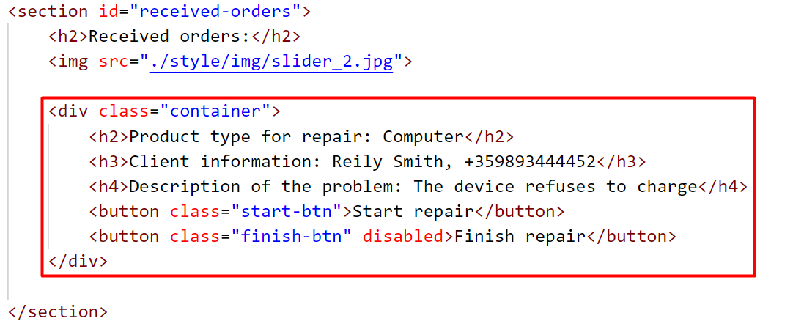

**Note:** When an order is successfully added, the button **["**Finish repair**"**] must be **disabled,** as the order cannot be completed if it has not started (Once the button is **disabled**, its color will turn gray).

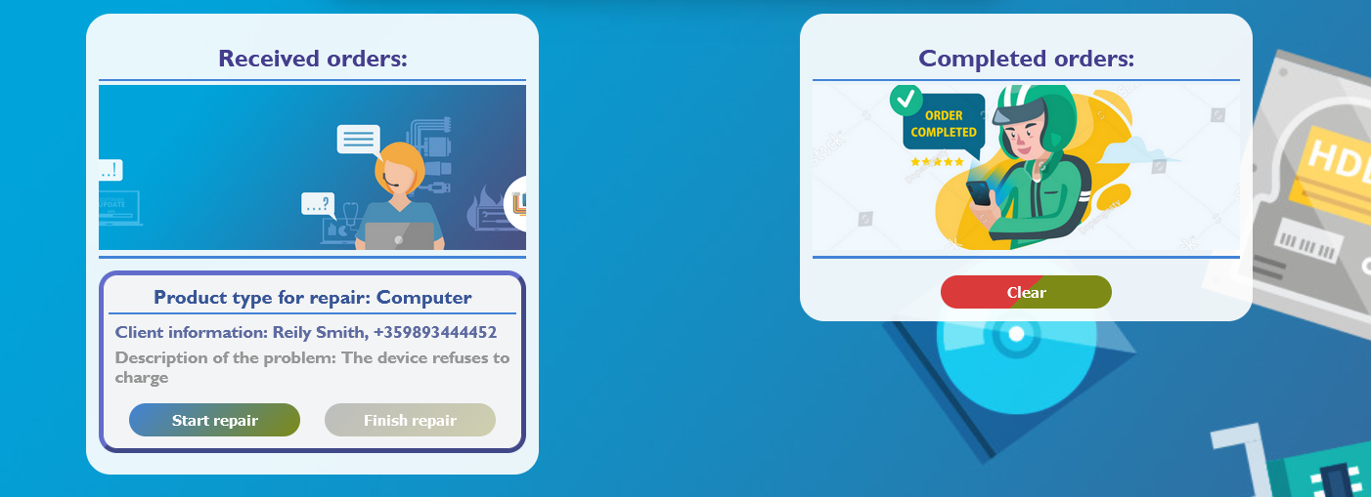

* When the **["**Start repair**"**] button is clicked, repair on the device begins. Since the process has already started, the worker will not be allowed to restart it, so the **["**Start repair**"**] button must be **disabled.** (Once the button is **disabled**, its color will turn gray).
* 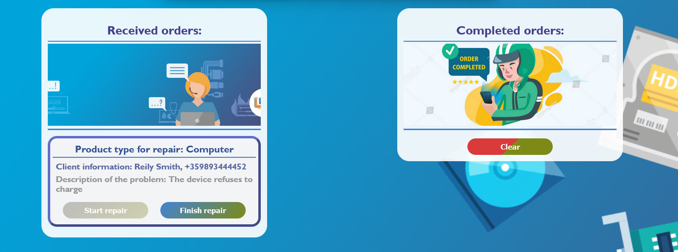Button **["**Finish repair**"**] must become activated.
* 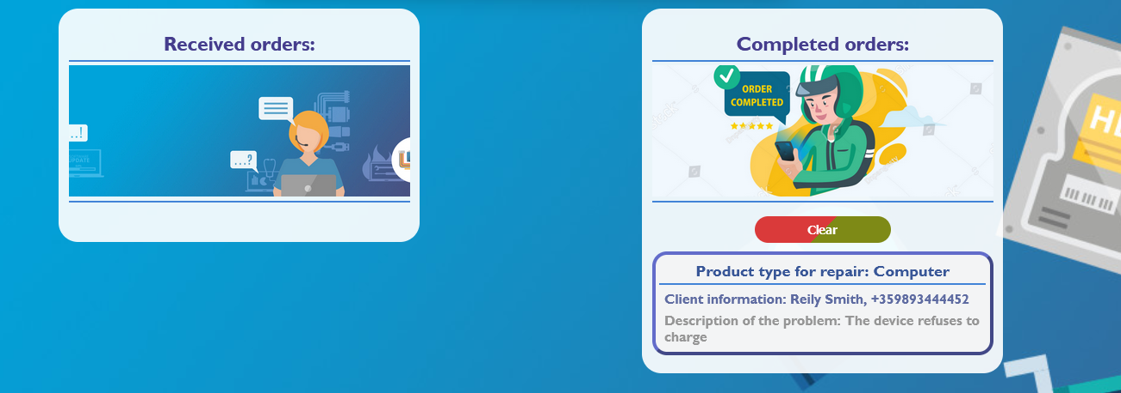When the **["**Finish repair**"**] button is clicked, repair on the device is complete. Therefore, you need to move the current device in the **section** with the **id** **"completed-orders"**.
* The HTML structure looks like this:

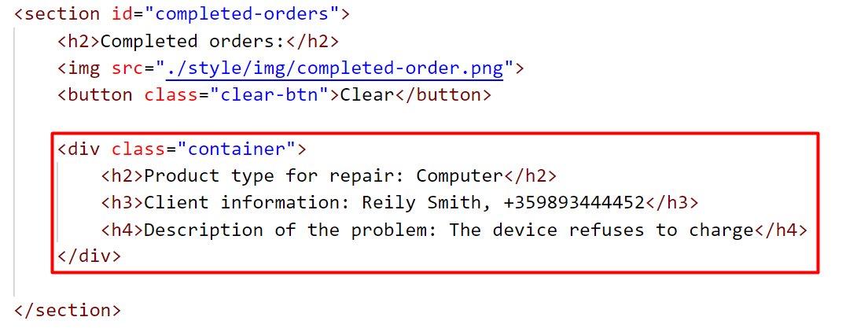

* 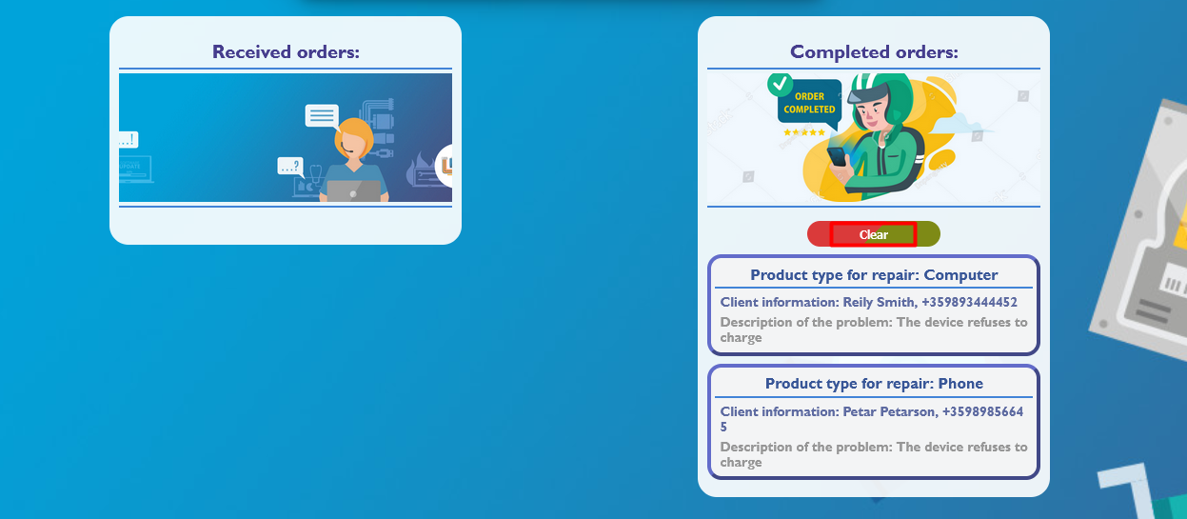When you click the **["**Clear**"**] button, you must **remove** all added **div** elements with **class** **"container"** from the section **Completed orders**.
* The HTML structure looks like this:

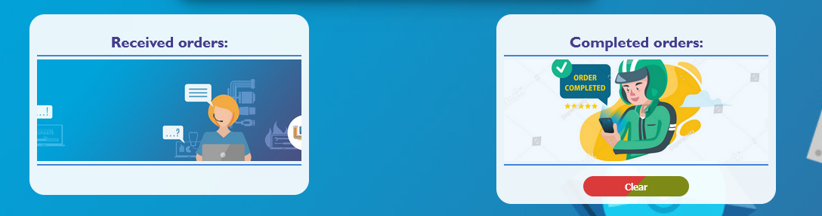

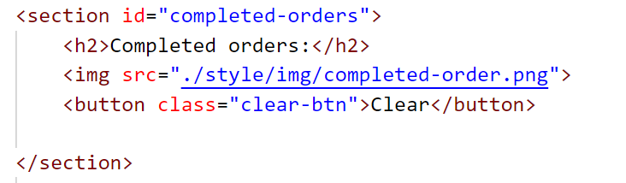

## Problem 2. Vegetable store

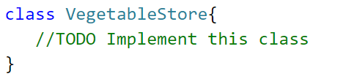

Write a **class Vegetable store**, which supports the described functionality below.

**Functionality**

**Constructor**

Should have these **3** properties:

* **owner - string**
* **location - string**
* **availableProducts - empty array**

**At the initialization** of the **VegetableStore** class, the **constructor** accepts the **owner** and **location.**

**Hint:** You can add more properties to help you finish the task.

### loadingVegetables (vegetables)

This method makes loading of the products in the store. The method takes 1 argument: **vegetables (array of strings)**.

* **Every element** into this array is information about vegetable in the format:

**"{type} {quantity} {price}"**

* They are separated by a single space. The **quantity** and **price** are per unit kilogram. **Example**: ["**Okra 2.5** **3.5**"**,** **"Beans** **10** **2.8", "Celery 5.5 2.2"…**]
* If the **type** of the current vegetable is already present in **availableProducts** array, add the new quantity to the old one and update the old price per kilogram **only if** the current one is **higher**.
* Otherwise, should **add** the vegetable, with properties: **{type, quantity, price}** to the **availableProducts array**.
* In all cases, you must **finally return a string** in the following format:

**`Successfully added {type1}, {type2}, …{typeN}`**

**Note**: When returning the **string**, keep in mind that the different **types** of **vegetables** **must** be:

* **Unique** -for instance**:** 
  + **"Successfully added Okra, Beans, Celery"** - is a correctly returned string
  + **"Successfully added Okra, Beans, Okra"** - is not a correctly returned string
* **Separated** by **comma** and **space (, )**

### buyingVegetables (selectedProducts)

With this method, customers can buy products from the store. The method takes 1 argument: **selectedProducts (array of strings)**.

* **Every element** in this array is information about the selected vegetables in the format:

**"{type} {quantity}"**

* For each element of the array **selectedProducts**, check:
  + If the **type** of the current vegetable is not present in **availableProducts** array, an error with the following message should be **thrown**:

**`{type} is not available in the store,** **your current bill is ${totalPrice}.`**

* + - **totalPrice -** is the total price of all customer's **purchases**, if there are **no** purchases yet the **value** should **be 0.00.**
  + If the **quantity** selected by the customer for a given vegetable **is greater** than the quantity recorded in the array **availableProducts**,an error with the following message should be **thrown**:

**`The quantity {quantity} for the vegetable {type} is not available in the store, your current bill is ${totalPrice}.`**

* + - **totalPrice -** is the total price of all customer's **purchases**, if there are **no** purchases yet the **value** should **be 0.00.**
  + Otherwise, if the above conditions are not met, you have to **calculate** the **price** for the given vegetable by **multiplying** the price per kilogram for the **given type** by the **quantity** desired by the customer. Then reduce the quantity recorded in the **availableProducts** array.
  + **Note:** **Add** a **variable** that will calculate the **total price** obtained from the individual prices of **each** vegetable in the array.
* Finally, you need to **return** the string in the following format:

**`Great choice! You must pay the following amount ${totalPrice}.`**

**Note:** The **totalPrice** must be rounded to the second decimal point and **before** the **price** must have a **dollar sign** (**$**).

### rottingVegetable (type, quantity)

With this method, the freshness of the vegetables in the store is preserved, removing the rotting vegetables. The method takes 2 arguments:

* **type (string)**
* **quantity (number)**
* If the submitted **type** is not present in the **availableProducts** array, an error with the following message should be **thrown**:

**`{type} is not available in the store.`**

* If the submitted **quantity is greater** than the quantity recorded in the **availableProducts** array, then the **value** of the quantity in the array becomes **zero,** and **return** the **following string:**

**`The entire quantity of the {type} has been removed.`**

* Otherwise, reduce the **quantity** recorded in the array **availableProducts** with the quantity obtained as a parameter, and **return** the string in the following format:

**`Some quantity of the {type} has been removed.`**

### revision ()

* This method **returns** **all** available **products** in the store in the following format:
* The first line shows the following message:

**"Available vegetables:"**

* On the new line, display information about each vegetable sorted in **ascending** order of **price**:

**`{type}-{quantity}-${price}`**

* The last line shows the following message:

**`The owner of the store is {owner}, and the location is {location}.`**

### Example

|  |
| --- |
| **Input 1** |
| let vegStore = new VegetableStore("Jerrie Munro", "1463 Pette Kyosheta, Sofia");  console.log(vegStore.loadingVegetables(["Okra 2.5 3.5", "Beans 10 2.8", "Celery 5.5 2.2", "Celery 0.5 2.5"])); |

|  |
| --- |
| **Output 1** |
| **Successfully added Okra, Beans, Celery** |

|  |
| --- |
| **Input 2** |
| let vegStore = new VegetableStore("Jerrie Munro", "1463 Pette Kyosheta, Sofia");  console.log(vegStore.loadingVegetables(["Okra 2.5 3.5", "Beans 10 2.8", "Celery 5.5 2.2", "Celery 0.5 2.5"]));  console.log(vegStore.buyingVegetables(["Okra 1"]));  console.log(vegStore.buyingVegetables(["Beans 8", "Okra 1.5"]));  console.log(vegStore.buyingVegetables(["Banana 1", "Beans 2"])); |

|  |
| --- |
| **Output 2** |
| **Successfully added Okra, Beans, Celery**  **Great choice! You must pay the following amount $3.50.**  **Great choice! You must pay the following amount $27.65.**  **Uncaught Error: Banana is not available in the store, your current bill is $0.00.** |

|  |
| --- |
| **Input 3** |
| let vegStore = new VegetableStore("Jerrie Munro", "1463 Pette Kyosheta, Sofia");  console.log(vegStore.loadingVegetables(["Okra 2.5 3.5", "Beans 10 2.8", "Celery 5.5 2.2", "Celery 0.5 2.5"]));  console.log(vegStore.rottingVegetable("Okra", 1));  console.log(vegStore.rottingVegetable("Okra", 2.5));  console.log(vegStore.buyingVegetables(["Beans 8", "Okra 1.5"])); |

|  |
| --- |
| **Output 3** |
| **Successfully added Okra, Beans, Celery**  **Some quantity of the Okra has been removed.**  **The entire quantity of the Okra has been removed.**  **Uncaught Error: The quantity 1.5 for the vegetable Okra is not available in the store, your current bill is $22.40.** |

|  |
| --- |
| **Input 4** |
| let vegStore = new VegetableStore("Jerrie Munro", "1463 Pette Kyosheta, Sofia");  console.log(vegStore.loadingVegetables(["Okra 2.5 3.5", "Beans 10 2.8", "Celery 5.5 2.2", "Celery 0.5 2.5"]));  console.log(vegStore.rottingVegetable("Okra", 1));  console.log(vegStore.rottingVegetable("Okra", 2.5));  console.log(vegStore.buyingVegetables(["Beans 8", "Celery 1.5"]));  console.log(vegStore.revision()); |

|  |
| --- |
| **Output 4** |
| **Successfully added Okra, Beans, Celery**  **Some quantity of the Okra has been removed.**  **The entire quantity of the Okra has been removed.**  **Great choice! You must pay the following amount $26.15.**  **Available vegetables:**  **Celery-4.5-$2.5**  **Beans-2-$2.8**  **Okra-0-$3.5**  **The owner of the store is Jerrie Munro, and the location is 1463 Pette Kyosheta, Sofia.** |

**Problem 3. Unit Testing**

**Your Task**

Using **Mocha** and **Chai** write **JS Unit Tests** to test a variable named **companyAdministration**, which represents an object. You may use the following code as a template:

|  |
| --- |
| describe(**"*Tests* …"**, **function**() {  describe(**"*TODO* …"**, **function**() {  ***it***(**"*TODO …*"**, **function**() {  *//* ***TODO:*** …  });  });  *//* ***TODO:*** …  }); |

The object that should have the following functionality:

**hiringEmployee (name, position,** **yearsExperience) -** A function that accepts three parameters: **string**, **string**, and **number**.

* If the value of the string **position** is different from "**Programmer**", **throw** an error: **`We are not looking for workers for this position.`**
* To be hired, the **employee** must meet the **following requirement**:
  + If the **yearsЕxperience** are **greater** than or equal to **3**, **return** the string:

**`{name} was successfully hired for the position {position}.`**

* Otherwise, if the above conditions are not met, **return** the following message:

**`{name} is not approved for this position.`**

* There is **no** need for **validation** for the **input**, you will always be given string, string, and number.
* **calculateSalary (hours) -** A function that accepts one parameter: **number**.
* Workers in this company receive **equal** pay per **hour** and this is **BGN 15**.
* You need to **calculate** the salary by **multiplying** the pay **for one hour** by the number of **hours**.
* **Also**, if the employee has been working for **more than 160 hours**, he must receive an additional **BGN 1000 bonus.**
* Finally, **return** the employee's salary.
* You need to validate the input, if the **hours** are not a **number**, or are a **negative** number, **throw** an error: "**Invalid hours**".
* **firedEmployee** **(employees, index) -** A function that accepts an array and number.
  + The **employees** array will store the names of its employees (["**Petar**", "**Ivan**", "**George**"…]).
  + You must **remove** an **element** (employee) from the **array** that is located on the **index** specified as a parameter.
* Finally, **return** the changed array of employees as a string, **joined** by a **comma** and a **space**.
  + There is a need for validation for the input, an **array** and index may not always be valid. In case of submitted **invalid** parameters, **throw** an error "**Invalid input**":
    - If passed **employees** parameteris not an array.
    - If the **index** is not a number and is outside the limits of the array.

**JS Code**

To ease you in the process, you are provided with an implementation that meets all of the specification requirements for the **companyAdministration** object:

|  |
| --- |
| companyAdministration.js |
| const companyAdministration = {      hiringEmployee(name, position, yearsExperience) {          if (position == "Programmer") {              if (yearsExperience >= 3) {                  return `${name} was successfully hired for the position ${position}.`;              } else {                  return `${name} is not approved for this position.`;              }          }          throw new Error(`We are not looking for workers for this position.`);      },      calculateSalary(hours) {          let payPerHour = 15;          let totalAmount = payPerHour * hours;          if (typeof hours !== "number" || hours < 0) {              throw new Error("Invalid hours");          } else if (hours > 160) {              totalAmount += 1000;          }          return totalAmount;      },      firedEmployee(employees, index) {          let result = [];          if (!Array.isArray(employees) || !Number.isInteger(index) || index < 0 || index >= employees.length) {              throw new Error("Invalid input");          }          for (let i = 0; i < employees.length; i++) {              if (i !== index) {                  result.push(employees[i]);              }          }          return result.join(", ");      }} |

**Submission**

Submit your tests inside a **describe()** statement, as shown above.